**An assessment of minimum income needs, subjective poverty levels and equivalence factors.**

By

**Bernice Macquela**

Submitted in partial fulfilment of the requirements for the degree Masters in Economics in the Faculty of Economic and Management Sciences

University of Pretoria



Supervisor : Professor Steve Koch

# Introduction

Over the years the measurement of poverty and inequality has become a point of focus for economists and policymakers, particularly in countries like South Africa, where the poverty rates remain high, and income disparities are stark (Leibbrandt et al., 2012). In determining poverty rates, the method employed by Statistics South Africa is an absolute poverty line where they set three primary thresholds: the upper-bound, lower-bound and food poverty lines (Statistics South Africa, 2022). These lines are constructed using the cost-of-basic-needs approach which links welfare to the consumption of goods and services, basically computing the cost of basic needs based on the reported consumption expenditures (Statistics South Africa, 2021). Money-metric measures, such as the South African poverty line, aid in providing a tool for the statistical measurement of poverty. However, the use of an absolute approach to poverty establishes a fixed amount that, even after accounting for inflation, does not alter over time to reflect changes in general living standards or costs.

Some studies (Seekings, 2007; Meth & Dias, 2004), although underlining the importance of money-metric measures in setting a threshold, argue that poverty measures based on income and expenditure ignore the non-income components of living standards. Others argue that money-metric measures are insufficient for evaluating well-being as they are insensitive to fluctuations that are caused by differences in household size and other factors within a household (Posel et al., 2020; Ravallion & Lokshin, 2002; Zwane, 2018). Additionally, money-metric measures may be inaccurate in assessing the degree of poverty if the expenditures or income measures used are not closely linked to the various aspects of the household’s living standards (Posel & Rogan, 2014). Thus, when using income or expenditure to assess economic well-being, it is important to consider individual or household differences in characteristics that affect needs. These differences could be household size and composition, regional cost of living differences and subjective perceptions of well-being (Daley et al., 2020). Some researchers have attempted to rectify this by accounting for household structure and regional differences in assessing multidimensional poverty in South Africa (Megbowan, 2018; Fransman & Yu, 2019). However, this approach does not account for economies of scale in income or expenditure (for example, a family of two may require more money than a single person but not twice as much), nor does it account for the difference in requirements for adults versus children (Daley, et al., 2020).

One alternative way is by employing a subjective income poverty approach, which is based on the “happiness and economics” literature (Ravallion, 2014; Ferrer-i-Carbonell & Van Praag, 2003). This subjective income poverty approach uses responses to the Minimum Income Questions (MINQ) and seeks to close the gap by assessing individuals’ perceptions of the minimum required income for an acceptable standard of living (Goedhart et al., 1977). The MINQ lets households report the minimum net income they estimate is necessary to “get by”, capturing a broader range of welfare components that differ by family type, size and geographic location (Byaruhanga et al.,2017; Wang, et al., 2020). Assessing subjective poverty can provide additional insights into how households perceive their economic well-being in relation to their actual income, highlighting disparities that objective measures might miss. This is because subjective measures are not dependent on pre-determined, expert-derived poverty thresholds (Ravallion & Lokshin, 2001). Using the subjective poverty approach gives the benefit of not only better understanding some of the roles and robustness of various determinants of poverty but can also help us detect the key determinants that policy initiatives should focus on (Dartanto & Otsubo, 2013).

Despite the existing body of research on poverty in South Africa (Woolard & Leibbrant, 1999; Daley et al., 2020; Posel & Rogan, 2014), there are some gaps remaining regarding the role of household dynamics and regional disparities. There are also gaps in what these differences mean in determining a subjective poverty level. Thus, the purpose of this study is to better understand how subjective income levels vary across South African households as well as using the MINQ to capture these differences. This research builds on earlier studies that use the MINQ to explore subjective poverty (Goedhart et al., 1977; Kapteyn et al., 1988). This study explores how a households’ perceived minimum income can vary due to differences in the household size, composition, geographic location and the settlement type. This research aims to provide new insights into the evolving socio-economic landscape of South Africa by using the 2014/2015 living Conditions survey. This work follows a similar method to Wang et al., (2020), in which an OLS regression is computed, and the coefficients are then utilized to estimate subjective poverty lines.

The findings reveal that household composition plays a critical role in shaping income needs, where households with one of more adults have higher subjective poverty levels, and households with three or more adults have lower levels. The results vary with the effect of children within a household, thus further research would be needed to see the effect of children at different ages. The results further highlight significant disparities in subjective poverty thresholds, with households in urban formal areas requiring higher minimum incomes compared to rural and traditional areas

The structure of the paper is as follows: Section 2 is a review of the literature that looks at the early theories of using subjective measures, like the minimum income question, to gauge people's perceptions of poverty. It also looks at the studies of subjective poverty carried out in South Africa and the shift to using the minimum income question in estimating equivalency scales to better understand changes within households. The data and methodology used in the study are then covered in Section 3, and the results and discussion are covered in Section 4. The conclusion, included in Section 5, provides a summary of the main conclusions of the study.

# Literature Review

One of the earliest estimations of subjective poverty measures (Goedhart, et al., 1977) introduces the idea of developing a poverty line using the Minimum Income Question (MINQ). The authors argue that people's opinions of the minimal income required are positively correlated with their own income and family size. As a result, income levels were found to vary according to family size. Kapteyn et al. (1988) extended this body of work by demonstrating that the MINQ can be utilized as a tool for evaluating subjective poverty by stressing its ability to capture an individual's perceived income adequacy. The reason for this is that by asking people what their minimum income is, it can take into consideration differences in living expenses that are driven by demographics and geography. This approach is also linked to the subjective welfare function of income, as proposed by Van Praag (1971), which attempts to capture how individuals perceive and evaluate their well-being in relation to income levels rather than assuming a one-size-fits-all welfare approach.

Over time other studies on the use of subjective measures of poverty using the MINQ have further reinforced early theories by showcasing some advantages in using this method. For example, Flik & Van Praag (1991) highlighted the utility of subjective data in understanding poverty dynamics across heterogenous populations. Additionally, Rojas (2008) utilizes the MINQ question was to measure subjective poverty and finds that a large number of households that are deemed "non-poor" by money-metric metrics still perceive themselves as impoverishment because of factors beyond income such as household composition and regional cost variations. Other studies that used the same methodology found that the more individuals there are in a household, the more income is needed to maintain the household's standard of living when (Vermeulen, 2002; Lanjouw & Ravallion, 1995). These studies demonstrate how subjective metrics of poverty could pick up on elements of other elements of poverty that objective metrics can overlook.

The MINQ has certain limitations when it comes to poverty assessments. Studies that assess subjective measures of poverty have the disadvantage of potentially being inaccurate because they may reflect respondents' aspirations rather than their actual living conditions, even though respondents may self-report their levels of poverty (Kapteyn et al., 1978; Ravallion & Lokshin, 2002; Sen, 1983). It is recommended that subjective poverty studies be utilized in conjunction with money-metric data rather than in substitute of them in order to provide a more composite measure of poverty (Posel & Rogan, 2014).

In some instances, poverty and inequality analysis rely heavily on equivalence scales, as these scales enable comparisons of income from households of different size and composition (Falter, 2004). An equivalence scale can be defined as a scale that adjusts household income to the degree of economic efficiency of household size and compares welfare levels for each household receiving from income in the same standard (Urakawa & Tokudomi, 2019). There are different approaches to estimating equivalence scales, including expert-based scales, demand system derived scales and subjective equivalence scales.

There is a growing body of literature that uses data on subjective perceptions of economic well-being to derive equivalence scales. Examples of these studies include using income evaluation or minimum income questions (Bishop et al, 2014; Garner & De Vos, 1995; Mysikova et al., 2021; Kapteyn et al., 1988). The subjective approach to estimating equivalence scales recognizes that poverty lines are based on an individual or households’ perception on what constitutes an acceptable standard of living in a certain society (Ravallion, 1992). One approach in estimating equivalence scales is the intersection approach, introduced by Goedhart et al., (1977), where the individuals’ perceptions of their minimum income needed aligns with their actual income. In several of these studies, the MINQ is used to estimate the income needed for a household of a specific composition to reach what they consider an acceptable quality of living. These studies (Bishop et al., 2014; Mysikova et al., 2021) typically use a single-adult reference home.

Bishop et al. (2014) calculated subjective equivalency scales for Euro Zone nations in comparison to objective OECD scales and discovered that subjective scales exhibit larger economies of scale within a household than objective scales. Furthermore, they discovered that subjective measures suggest a decreasing marginal cost of adding children, whilst the OECD and NRC scales show a constant marginal cost of children. Mysikova et al. (2021) employed a different technique, utilizing the MINQ to first estimate subjective poverty lines, which were then used to generate equivalency scales for EU countries and compared them to the modified OECD scales. Similar to the findings of Bishop et al. (2014), they discover that subjective scales exhibit greater economies of scale than modified OECD scales. They also discover that wealthy countries have superior economies of scale due to their stronger welfare programs. Both of these investigations are based on the intersection methodology established by Goedhart et al. (1977). Because of the intersection methodology, there ends up being a convergence between subjective equivalence scales and subjective poverty lines as both of these poverty assessments are mainly based on the MINQ.

In South Africa, much of the equivalency scale research uses a parametric or semiparametric scale approach to quantify individual or household income or expenditure (Posel et al., 2016; Rogan, 2012; Yatchew et al., 2003; Posel et al., 2020; Koch, 2022). Posel et al., 2020 estimated equivalence scales for South Africa using the Engel technique, which takes into account the share of a household's expenditure allocated to food. They found that compared to non-African households, African households experience larger economies of scale in household consumption. They also found that children consume less than adults do. Using a different data set and a similar Engel technique, Koch (2022) estimated equivalence scales based on a household's portion of the food budget using the 2014-2015 Living Conditions Survey. According to the study's findings, food shares are higher in bigger households at almost every spending level; however, the increase seems to be less pronounced as family sizes increase, suggesting that there may be household economies of scale. In contrast to Posel et al. (2020), their data also shows that households with youngsters spend comparatively more than households with just adults. However, when it comes to subjective equivalence scales in South Africa, there is limited research available. Among this research is that by Koch (2023), which focuses on the adequacy of basic needs using data from the 2014–2015 Living Conditions Survey. In order to compare subjective and objective measures of poverty, the study uses a households self-assessed adequacy of food, clothing and housing to estimate subjective poverty scales. Although these scales offer a different view on poverty in South Africa, they mostly rely on objective methods or subjective data instead of the MINQ.

Subjective poverty assessments in South Africa that are based on the MINQ are also limited, with subjective poverty studies looking at either self-assessments of their economic status (Posel & Rogan, 2014), assessments of their life satisfaction (Moller and Saris, 2001) or the determinants of subjective poverty (Bila & Biyase, 2022). Moller and Saris (2001) used the 1995 Quality of Life Trends study to assess subjective poverty with the aim of examining subjective well-being across racial groups. Their study found that there were significant racial inequalities within the country, with Black South Africans reporting higher levels of subjective poverty compared to other racial groups. Bookwalter and Dalenburg (2004) used the 1994 South African Labour and Development Research Unit (SALDRU) data in their analysis of subjective poverty where they found that transportation and housing significantly influence subjective well-being, especially for rural households

Posel & Rogan (2014) used the 2008-2009 LCS where respondents were asked to rate themselves from very poor to wealthy to estimate subjective poverty lines in South Africa. Their findings reveal that a household’s self-assessed level of poverty increases as the size of the household increases. Additionally, they found that larger families benefit from economies of scale and resource sharing and that there can be differences in the cost of living due to some wealthier provinces having higher costs of living. Bila & Biyase (2022) looked at the determinants of subjective poverty using the 2014-2015 LCS, with the aim of examining the impact of gender, education, marital status and locality on subjective poverty. They found that factors such as landownership and access to services have an effect on rural households’ subjective poverty. Whereas urban households are more likely to be affected by unemployment and health conditions. In general, they discovered that in South Africa, variables like income, employment, household size and geographic location play a role in how poverty is defined.

Despite these contributions, South African research does not have a focused examination of subjective poverty lines using the MINQ. Most studies rely on alternative subjective measures, leaving gaps in our understanding of how minimum income perceptions vary across household consumptions and regions. This study aims to fill this gap by using the using the 2014-2015 LCS to estimate subjective poverty lines for households based on the MINQ.

# Data and methodology

## Data

The data used in this study is from the 2014-2015 South African Living Conditions Survey (LCS) which was collected by Statistics South Africa. The survey contains data regarding household and individual variables such as household assets, household expenditures, employment statuses, gender and age. Although there are other surveys in South Africa that look at these variables such as the General Household Survey, however the LCS contains the MINQ question which is an important part of the analysis of this paper.

Three data files from the LCS were combined to create the data used in the analysis: the households data file, the individual’s data file, and the total data file. An initial total of 23380 households was obtained by combining these three datasets. The "age" variable in the dataset was used to generate the Children and Adults data, classifying all individuals under the age of 15 as children and all adults living in a home over the age of 15 as adults. After merging, the dataset was filtered to remove zero values from the MINQ variable, which eliminated 504 observations, and zero values from the income-in-kind data, which eliminated 55 observations, leaving 22821 observations. The list of variables used in this analysis are shown in Table 7‑1 which can be found in the Appendix.

The analysis' dependent variable is the bare minimum of income that households require to survive. At first, the survey responses were presented as annual figures. The data was first converted to monthly numbers and then log transformed for the analysis. This was carried out because the MINQ distribution appears to be heavily skewed to the right, with a lengthy tail that extends to higher values. This suggests that while the majority of households report having modest minimal incomes, some have extremely high minimum income requirements, resulting in outliers. This is in line with the high-income inequality prevalent in the Country. However, the distribution of the logged minq seems to be more normally distributed and more symmetrical. Thus, the log transformation of MINQ compresses the scale of larger values which makes it easier to analyse and interpret the data.

Log transformations are important in trying to stabilize variance as well as mitigate the impact of extreme values, particularly when analysing income data which often exhibits skewness (Gujarati, 2009). Therefore, all values shown in the analysis are shown at the monthly level.

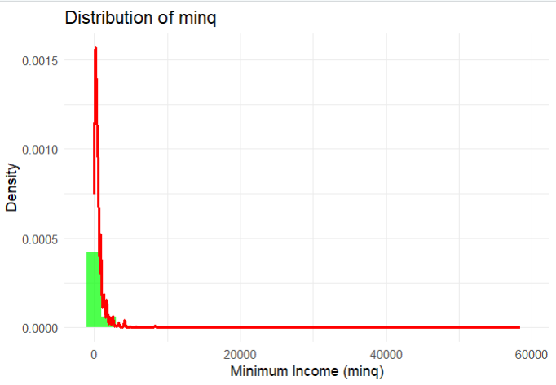

Figure 3‑1: Distribution of Monthly Minimum Income Needed (MINQ)

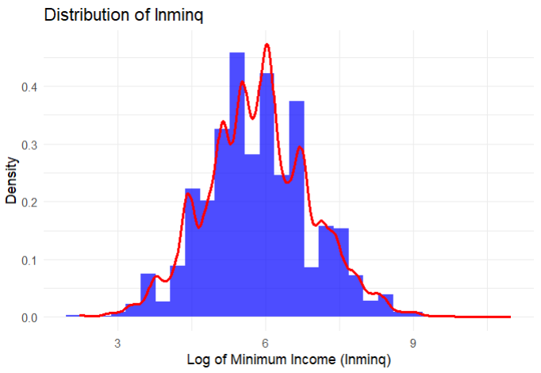

Figure 3‑2: Distribution of Log of Monthly Minimum Income (LnMINQ)

The independent variable is household income in kind. This variable was likewise changed into a monthly value, which was then log transformed. This method is in line with research conducted by Ravallion & Lokshin (2002). They focused on income than expenditure to determine poverty levels. The decision to focus on income is based on the fact that it offers a perspective of a household’s situation by including both earned and in-kind sources of income. Furthermore, in assessing minimum requirements, income acts as a gauge of a household’s ability to attain a satisfactory quality of life as it represents the overall resources, at their disposal, for fulfilling crucial costs.

Control variables are also added to the analysis. These control variables represent the different household demographics such as household size and location. This is done to assess the relationship that different household demographics have to the minimum income needs. These variables include:

* Household Composition: the proportion of adults and children living in the household. This is evaluated in two parts. The first one uses the household of one adult and no children as the basis for the analysis and looks at the number of adults and children as dummies. The second is where adults and children are viewed as a continuous variable. In the dummy variable approach, the number of children and adults within a household are capped 6 because the number of households with more than 6 children and 6 adults is relatively small within the dataset.
* Geographical Variables: The different provinces within the country are also assessed, with the baseline province being households in the Northwest, and
* Location Variables: Settlement types are also factored in where the baseline are households in rural formal areas

## Model Specification

Utilizing a methodology similar to that of Wang et al., (2020) we start by estimating equation (1). This is done using Ordinary Least Squares (OLS) regressions with robust standard errors.

$lnMINQ=B_{0}+B_{1}lny+B_{2}(ln{y)}^{2}$ (1)

An initial analysis of the relationship between lnminq and lny shows that the relationship is nonlinear, therefore a simple linear equation will not be sufficient in reflecting this relationship. In order to rectify this, a quadratic component is added to the regression relationship which will assist in capturing the relationships curvature.

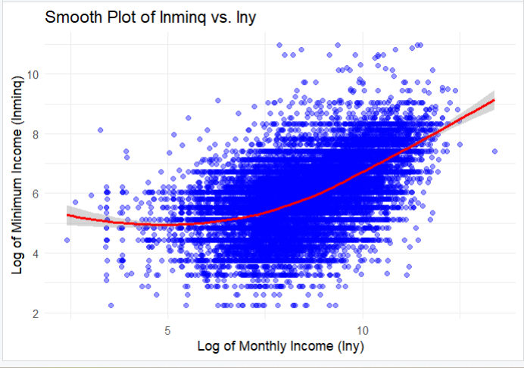

Figure 3‑3: Smooth plot of lnminq against lny

$lnMINQ=B_{3}+B_{4}lny+B_{5}(ln{y)}^{2} +\sum_{j=1}^{5}{γ_{j}}{Adults}_{j}+\sum_{j=1}^{6}{δ_{j}}{Children}_{i}$ (2)

$lnMINQ=B_{6}+B_{7}lny+B_{8}(ln{y)}^{2}+\sum_{j=1}^{5}{γ_{j}}{Adults}_{j}+\sum_{j=1}^{6}{δ_{j}}{Children}_{i}+\sum_{j=1}^{8}{θ_{j}{Province}_{i}}+ \sum_{j=1}^{3}{a_{j}}Settlement Type+ε$ (3)

MINQ represents the monthly minimum income needed in the household, Y is the monthly household income, Adults is the set of dummy variables that represent the number of adults within a household, Children is the set of dummy variables that represent the number of children in the household and Province is the set of dummy variables that represent the province location. The base is a single person household with no children. $B_{0}, B_{1},$ $γ_{j}, δ_{j}$ and $a_{j}$ are the parameters to be estimated. $ε$ is the error term.

We estimate equation 1 to examine the relationship between a household's minimum income and its actual income. The second equation adds household composition to see how that impacts the minimum income needed by a household. The third equation looks at how the minimum income needed is further affected by the province that households are in, as well as how settlement kinds affect it. The models do not include interaction terms or household-level random effects for simplicity. However, the regressions should be interpreted as being for each household, with the predictors capturing differences across households based on their composition and location.

To estimate the subjective poverty lines for each household type, we use a similar equation to the one shown in Equation 3. The OLS coefficients are applied as follows:

$SPL={\hat{B}}_{0}+{\hat{B}}_{1}lny+{\hat{B}}_{2}{\left(lny\right)}^{2}+\sum_{j=1}^{6}{{\hat{γ}}_{j}}{Adults}_{j}+\sum_{j=1}^{6}{{\hat{δ}}_{j}}{Children}_{i}+\sum_{j=1}^{9}{{{\hat{θ}}_{j}Province}_{i}}+\sum_{j=1}^{3}{{\hat{a}}_{j}}Settlement Type$ (4)

# Results and Discussion

## Descriptive Statistics

The descriptive statistics provide an overview of household characteristics and income distributions which are shown in Table *4*‑*1* and Table *4*‑*2*. The average monthly log of household income (lny) is 8.40, whereas the mean monthly minimum income needed (lnminq) is 5.85. From this, it seems that a household’s actual income is higher than their minimum income needed, which suggests that on average households perceive their minimum income needs to be lower than their actual income.

The descriptive statistics show that on average a household in the dataset is made up of four individuals, with 3 adults and 1 child. We see that majority of households in the data do not have children (44%), and that of those that do have children 21% have one child and 17% have two children. We also see that when it comes to the distribution of adults within a household, majority of the households in the data are made up of two adults (31%), followed by 25% of households consisting of just one adult. Households with a big number of adults seem to be less common as only 3% of households in the data have six adults.

In the dataset, the majority of households live in urban formal settlements (53%) whilst around 36% live in traditional areas. Additionally, we observe that KZN has the largest number of households in the dataset, accounting for 16% of all households.

Table 4‑1: Summary Statistics of the variables

|  |  |  |
| --- | --- | --- |
| Variable | Mean | St.Dev |
| Log of Minimum Income | 5.85 | 1.09 |
| Log of Household Income | 8.40 | 1.24 |
| Household size | 4 | 2.52 |
| Children | 1 | 1.46 |
| Adults | 3 | 1.53 |
| No Children | 0.44 | 0.49 |
| One Child | 0.21 | 0.10 |
| Two Children | 0.17 | 0.38 |
| Three Children | 0.09 | 0.28 |
| Four Children | 0.04 | 020 |
| Five Children | 0.02 | 0.13 |
| Six Children | 0.008 | 0.09 |
| One adult | 0.25 | 0.43 |
| Two adults | 0.32 | 0.46 |
| Three adults | 0.20 | 0.39 |
| Four adults | 0.12 | 0.32 |
| Five adults | 0.06 | 0.24 |
| Six adults | 0.03 | 0.17 |
| WC | 0.12 | 0.32 |
| EC | 0.13 | 0.33 |
| NC | 0.06 | 0.23 |
| FS | 0.09 | 0.29 |
| KZN | 0.16 | 0.36 |
| NW | 0.09 | 0.28 |
| GP | 0.14 | 0.34 |
| MP | 0.10 | 0.30 |
| LP | 0.12 | 0.33 |
| Urban Formal | 0.53 | 0.49 |
| Urban informal | 0.07 | 0.25 |
| Traditional | 0.36 | 0.47 |
| Rural Formal | 0.04 | 0.19 |

Table 4‑2: Mean monthly lnminq by number of adults and children in a household

|  |  |  |  |  |  |  |  |
| --- | --- | --- | --- | --- | --- | --- | --- |
| Adults | No Children | One Child | Two Children | Three Children | Four Children | Five Children | Six Children |
| 1 | 5.62 | 5.56 | 5.50 | 5.49 | 5.35 | 5.41 | 5.61 |
| 2 | 5.93 | 5.95 | 6.03 | 5.86 | 5.70 | 5.59 | 5.67 |
| 3 | 6.07 | 6.01 | 5.96 | 5.72 | 5.65 | 5.78 | 5.49 |
| 4 | 6.13 | 6.04 | 5.96 | 5.76 | 5.79 | 5.68 | 5.63 |
| 5 | 6.12 | 6.03 | 5.93 | 5.62 | 5.79 | 5.80 | 5.74 |
| 6 | 5.99 | 5.87 | 5.86 | 5.98 | 5.76 | 6.04 | 5.91 |

When we first compare the mean monthly incomes needed by the various households, we find that households with four adults and no children have the highest minimum income needs, while households with five adults and no children have a lnminq that is comparable to that. For instance, the lnminq for a household with four adults and no children is 6,13, while a household with five adults and no children has a lnminq of 6,12. Additionally, the lowest lnminq is found in households with one adult and four children.

Furthermore, we see that the lnminq is highest in households with no children and decreases as more children are added to households. Whereas in other households the presence of children tends to increase the lnminq but with diminishing returns as the number of children rises. For example, the lnminq rises from 5.93 in households with one adult and no children to 6.03 in households with two children, and then slightly falls in households with four or more children.

## Minimum Income Needed and Actual Income

The results of the relationship between the logged monthly minimum income needed (lnminq) and actual income are shown in column 2 of Table 7‑2. We see that there is a statistically significant negative relationship between lnminq and actual income. Additionally, the nonlinear relationship between lnminq and actual income is positive and statistically significant. This finding is in line with that of Rojas (2007) as well as that of Ferrer-i-Carbonell & Van Praag (2003) where they found that actual income is positively related to a households’ minimum income needs.

The R-squared shows that including income variables in the analysis of minimum income explains 30% of the variance. This shows that the needs of a given household are best captured by their actual income.

When looking at the other columns in Table 7‑2, we see that the inclusion of other variables such as children, adults, settlement type and provinces slightly changes the size of the coefficients attached to the income variable while the effect stays being constant.

## Household Size and Composition

### Household Composition Impact on Minimum Income

In assessing the impact of children on a households’ minimum income needs, we first look at children as a continuous variable as shown in Table 7‑3. The results indicate that the presence of children in a household will result in an increase in the minimum income needed. Including variables such as settlement type and province slightly increases the coefficients. However, the effect of children on a households’ minimum income needed is only statistically significant when both settlement type and province type is accounted for in the relationship. Similarly, Table 7‑3 shows the impact of adults on a households’ minimum income needs. At a continuous variable level, adults have a negative impact on the minimum income required, with the negative relationship being statistically significant with and without the inclusion of settlement type and province type variables.

At the dummy variable level, shown in Table 7‑2, the effect of children on minimum income needed provides a more informed understanding of the relationship. In this analysis we see that households of one or two children have a positive relationship with the minimum income needed. This suggests that households of two or more children have a higher minimum income requirement. Additionally, in households of three or more children, there is a negative relationship with the minimum income needed. When settlement type and province variables are included the relationship between number of children and minimum income changes. In this change we see that in households of three children there is still a negative relationship with minimum income needed, however all other compositions of children are now positive. Notably, only the effects of two and five children are statistically significant.

When looking at the effect of the number of adults in a household on the minimum income needed, we also see varying results. Households with two or three adults have a positive relationship with minimum income needs, whereas households with four adults or more have a negative relationship with minimum income needs. The inclusion of settlement type and province variables doesn’t result in a major change as the relationships remain constant. Notably, the effects of households with four adults or more on minimum income are statistically significant at all levels.

These findings are supported by that of Posel et al., (2020) who found that the addition of children and adults to a single person household will lead to an increase in the budget shares of a household, thus resulting in higher minimum income needs. The analysis revealed varied results in child and adult costs, similar to that of Koch (2022). However, the contrasting results in the effect of children on a households’ minimum income needs could be due to not factoring in different ages. Streak et al., (2008) found that in South Africa the poverty headcount is highest amongst children of the youngest age cohort, followed by the ages 5-14 and 15-17. This can also be due younger children having access to a child support grant. Furthermore, Bila & Biyase (2022) found that when examining subjective poverty, age is a statistically significant determinant in that analysis. Thus, accounting for different ages in children could provide more nuanced insights into the analysis of the effect of children and adults on minimum income needs.

### Subjective poverty lines by household size

The estimated subjective poverty lines based on household size are seen in Figure 4‑1. Households that have 1 and 2 children have the highest subjective poverty lines, and households with 6 children have the lowest subjective poverty line. Additionally, we see that households with 2 adults have the highest subjective poverty and households of 6 adults have the lowest poverty. This is in line with the finding of Posel & Rogan (2014) where the average costs of maintaining a certain standard of living decreases in larger households. These findings also support those of Bishop et al.,(2012) who found that the addition of 1 child to a household is more costly than adding a third child because the marginal cost of children in a household decreases. The results also show that the gap in subjective poverty lines between households with no children and households with 5 children in not that large, suggesting that these households have the same minimum income needs.

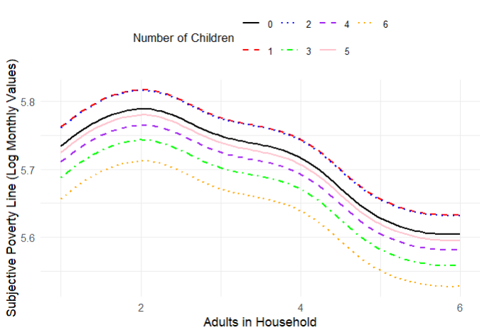

Figure 4‑1: Subjective Poverty Lines by Household Size

## Regional and Settlement Type Differences

### Provincial Variations

The addition of province variables in the analysis results in an increase in the R-squared from 31.8% to 39.8%, thus showing that accounting for provincial differences in subjective poverty is important (Table 7‑2). The baseline province in this analysis are households in Northwest. The analysis shows that households in KZN have lower minimum income needs than household in the Northwest, whereas households in every other province have higher minimum income needs. The analysis also shows that households in the Northern Cape, Free State and the Western Cape have higher minimum income needs than those in the Northwest.

The regional differences in minimum income needs could result in the cost-of-living differences. Research such as Garner & Short (2004) argues that households in provinces such as the Western Cape have higher costs for residents because of increased urbanization. Majority of the population in the Northern Cape live in urban areas which explains why households based in that province have high minimum income needs (StatsSA, 2022). Bishop et al., (2012) found that well-developed states have a greater economy of scale than that of less developed states.

Accounting for the regional variables in the estimation of subjective poverty lines causes a change in subjective poverty with households of 5 children having the highest subjective poverty line and households with 3 children having the lowest subjective poverty lines. However, the adult effects stay the same with households of 2 adults having the highest subjective poverty.

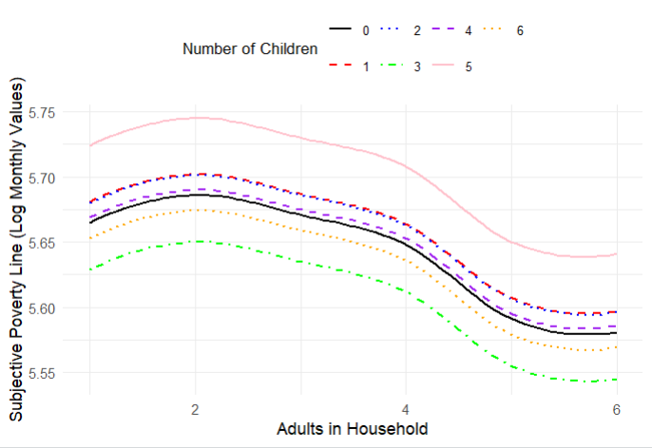

Figure 4‑2: Subjective Poverty Lines for Northwest Households

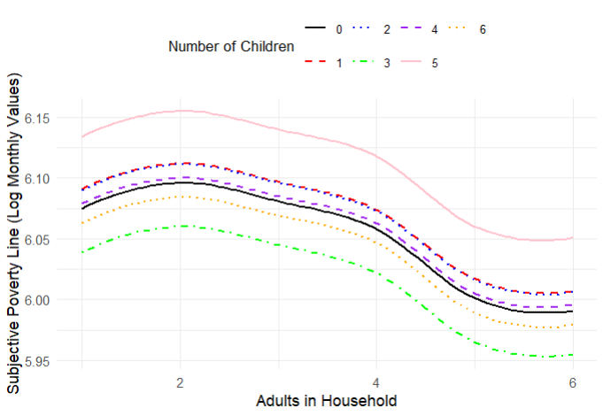

Figure 4‑3: Subjective Poverty Lines for Northern Cape Households

### Settlement Type Variations

Factoring in the settlement type variables in the analysis results in a 40% R-squared. The baseline in the analysis are households in rural settlements. The results suggest that households in urban formal areas have the highest minimum income requirement whereas households in traditional areas have a lower minimum income required compared to those in rural settlement types. All settlement type dummies have a statistically significant effect on minimum income needs.

The findings suggest that households in urban areas could have higher standards of living than those in rural areas. The difference in minimum income needs between households in rural and traditional areas are interesting as the assumption would be that households in traditional areas would have higher minimum income needs. Posel & Rogan (2014) argue that households in rural areas are less likely to self-assess as poor due to these households having access to farming land which could be used for subsistence. Furthermore, Bila & Biyase (2022) found that in urban and rural settlements the determinants of subjective poverty differ significantly and that owning a piece of land appears to be important for households in rural areas. Conversely, the finding that households in urban settings have a higher minimum income need is further supported by that of Garner and Short (2004) who showed that urban households’ thresholds are shaped by higher financial demands and social expectations.

The impact of settlement types on subjective poverty lines shows that households consisting of 5 children still have the highest subjective poverty line and households with 3 children have the lowest subjective poverty line. The addition of settlement types also results in households of 6 children and 4 children having subjective poverty lines that are just below that of 5 children, and these lines are quite close. The minimum income required for families with more than two adults also show a slight fall, while households with more than four adults in a household experience a larger decline.

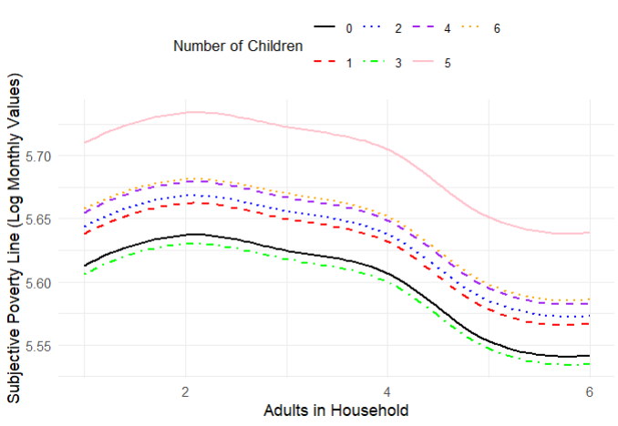

Figure 4‑4: Subjective Poverty Lines for Households in Rural Areas

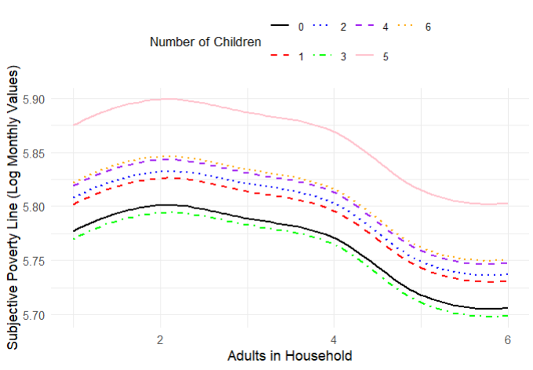

Figure 4‑5: Subjective Poverty Lines for Households in Urban Formal Areas

## Comparison of Subjective Poverty and Objective Measure

A final part of the analysis is a comparison of the subjective poverty lines and the 2015 objective poverty lines. The estimated subjective poverty lines are compared with two objective lines. First if the Food Poverty Line of R447, which represents the income needed to meet basic food requirements. The second is the Lower Bound Poverty Line of R647, which includes the food and non-food essentials that households need, but it is based on the assumption that households will sacrifice some essential items to afford food. Table 4‑3 shows the differences across these measures.

The findings reveal that the proportion of households that are considered poor are higher using the subjective poverty line compared to the Food Poverty Line. This finding is in accordance with that oh Posel & Rogan (2014) who found that the proportion of households that self-assess as poor are much higher than those of the objective poverty rate. However, the proportion of households that are considered poor using the subjective poverty line are lower than the lower bound poverty line. This suggests that households perceive their minimum income needs to be enough to cover their basic food needs, however still less than what the lower bound poverty line estimates is necessary for an adequate standard of living.

Additionally, the percentage of households that fall below the subjective poverty line is frequently near the percentage below the lower bound poverty line. This finding suggests that this analysis of subjective poverty only accounts not all factors are accounted for thus leading to poverty percentages that are close but could improve with the addition of more variables.

Table 4‑3: Comparison of households that fall below the different poverty measures

|  |  |  |  |  |  |  |
| --- | --- | --- | --- | --- | --- | --- |
| Adults | Children | SPL in Rands | Total Households | % Below SPL | % Below FPL | % Below LBPL |
| 1 | 0 | 532 | 4,289 | 74 | 71 | 77 |
| 1 | 1 | 541 | 617 | 78 | 75 | 82 |
| 1 | 2 | 540 | 451 | 81 | 77 | 83 |
| 1 | 3 | 513 | 202 | 84 | 83 | 86 |
| 1 | 4 | 535 | 67 | 96 | 94 | 97 |
| 1 | 5 | 565 | 21 | 95 | 90 | 95 |
| 1 | 6 | 526 | 9 | 100 | 78 | 100 |
| 2 | 0 | 543 | 3,263 | 65 | 61 | 68 |
| 2 | 1 | 552 | 1,738 | 65 | 60 | 68 |
| 2 | 2 | 552 | 1,424 | 64 | 59 | 67 |
| 2 | 3 | 524 | 621 | 72 | 68 | 75 |
| 2 | 4 | 546 | 220 | 76 | 71 | 80 |
| 2 | 5 | 577 | 58 | 84 | 78 | 88 |
| 2 | 6 | 537 | 22 | 86 | 86 | 91 |
| 3 | 0 | 535 | 1,476 | 61 | 56 | 64 |
| 3 | 1 | 544 | 1,189 | 65 | 61 | 68 |
| 3 | 2 | 543 | 960 | 67 | 62 | 70 |
| 3 | 3 | 516 | 529 | 75 | 68 | 78 |
| 3 | 4 | 538 | 202 | 75 | 68 | 79 |
| 3 | 5 | 568 | 87 | 83 | 74 | 86 |
| 3 | 6 | 529 | 41 | 90 | 90 | 90 |
| 4 | 0 | 523 | 694 | 60 | 54 | 63 |
| 4 | 1 | 532 | 753 | 62 | 58 | 66 |
| 4 | 2 | 531 | 630 | 66 | 60 | 69 |
| 4 | 3 | 505 | 358 | 74 | 70 | 78 |
| 4 | 4 | 526 | 206 | 74 | 68 | 79 |
| 4 | 5 | 556 | 91 | 86 | 80 | 89 |
| 4 | 6 | 517 | 42 | 90 | 79 | 90 |
| 5 | 0 | 494 | 256 | 55 | 54 | 65 |
| 5 | 1 | 502 | 336 | 61 | 56 | 66 |
| 5 | 2 | 502 | 305 | 66 | 59 | 70 |
| 5 | 3 | 477 | 198 | 75 | 75 | 81 |
| 5 | 4 | 497 | 141 | 67 | 67 | 79 |
| 5 | 5 | 525 | 76 | 80 | 71 | 84 |
| 5 | 6 | 488 | 19 | 79 | 79 | 84 |
| 6 | 0 | 489 | 90 | 61 | 61 | 70 |
| 6 | 1 | 497 | 143 | 63 | 62 | 70 |
| 6 | 2 | 497 | 138 | 64 | 63 | 71 |
| 6 | 3 | 472 | 105 | 66 | 66 | 74 |
| 6 | 4 | 492 | 80 | 68 | 68 | 79 |
| 6 | 5 | 520 | 33 | 64 | 55 | 64 |
| 6 | 6 | 483 | 31 | 61 | 61 | 74 |

# Conclusion

The purpose of the study was to find out how subjective poverty thresholds vary between households in South Africa, and this was done using the MINQ responses from the 2014/2015 Living Conditions Survey. This was done in order to find out how variations in household size and composition, geographical location and type of settlement influence the minimum income which a household requires and/or may be perceived to require for a comfortable living and what this implies in respect of poverty.

The study shows that household structure is a major factor in determining income requirements because households that contain one adult or more have higher minimum income requirements, while households that contain at least three adults or more have lower minimum income requirements. The results are different depending on the number of children in the household. The results also show distinct differences in the subjective poverty thresholds where households in urban formal settlements require higher a minimum income than those in rural and the traditional settlements. Furthermore, households in the Western Cape and Northen Cape have high minimum income requirements which show that the cost of living and access to resources are different based on the geographic location of a household.

There are some limitations and issues that can be explored in more detail in future research. For instance, there were some contradictions as to the relationship between subjective poverty and children. It would be useful for this relationship to be further examined by looking at how different ages and how they affect minimum income needs. Younger children may place higher demands on household needs than older children. Furthermore, examining subjective poverty patterns over time using longitudinal data may show how household views of poverty are impacted by changes in the economy and policy initiatives.

# References

Bila, S.N., 2021. Determinants of subjective poverty in rural and urban areas of South Africa. University of Johannesburg (South Africa).

Bila, S. and Biyase, M., 2022. Determinants of subjective poverty in rural and urban areas of South Africa. University of Johannesburg.

Bookwalter, J.T. and Dalenberg, D., 2004. Subjective well-being and household factors in South Africa. Social indicators research, 65, pp.333-353.

Byaruhanga, C., Davis, A., Mpike, M., Ntshongwana, P., Padley, M., Wright, G. and Zembe-Mkabile, W., 2017. A decent living level: A pilot of the minimum income standard approach in South Africa. Cape Town: SASPRI.

Daley, A., Garner, T., Phipps, S. and Sierminska, E., 2020. Differences across countries and time in household expenditure patterns: implications for the estimation of equivalence scales. International Review of Applied Economics, 34(6), pp.734-757.

Dartanto, T. and Otsubo, S., 2013. Measurements and determinants of multifaceted poverty: Absolute, relative, and subjective poverty in Indonesia.

Falter, J.M., 2004. Equivalence scales, poverty lines and subjective data in Switzerland. Poverty Lines and Subjective Data in Switzerland (November 2004).

Ferrer-i-Carbonell, A. and Van Praag, B.M., 2003. Income satisfaction inequality and its causes. The Journal of Economic Inequality, 1, pp.107-127.

Flik, R.J. and Van Praag, B.M., 1991. Subective poverty line definitions. De Economist, 139(3), pp.311-330.

Fransman, T. and Yu, D., 2019. Multidimensional poverty in South Africa in 2001–16. Development Southern Africa, 36(1), pp.50-79.

Goedhart, T., Halberstadt, V., Kapteyn, A. and Van Praag, B., 1977. The poverty line: Concept and measurement. Journal of human resources, pp.503-520.

Kapteyn, A. and Van Praag, B., 1978. A new approach to the construction of family equivalence scales. European Economic Review, 7(4), pp.313-335.

Kapteyn, A., Kooreman, P. and Willemse, R., 1988. Some methodological issues in the implementation of subjective poverty definitions. Journal of Human Resources, pp.222-242.

Koch, S.F., 2022. Equivalence scales in a developing country with extensive inequality. South African Journal of Economics, 90(4), pp.486-512.

Koch, S.F., 2023. Basic needs (in) security and subjective equivalence scales. Social Indicators Research, 169(3), pp.723-757.

Leibbrandt, M., Finn, A. and Woolard, I., 2012. Describing and decomposing post-apartheid income inequality in South Africa. Development Southern Africa, 29(1), pp.19-34.

Lewbel, A. and Pendakur, K., 2008. Equivalence scales. New Palgrave Dictionary of Economics, 3, pp.26-29.

Logan, T.D., 2011. Economies of scale in the household: Puzzles and patterns from the American past. Economic Inquiry, 49(4), pp.1008-1028.

Mahmood, T., Yu, X. and Klasen, S., 2019. Do the poor really feel poor? Comparing objective poverty with subjective poverty in Pakistan. Social Indicators Research, 142, pp.543-580.

Megbowon, E.T., 2018. Multidimensional poverty analysis of urban and rural households in South Africa. Studia Universitatis Babes Bolyai-Oeconomica, 63(1), pp.3-19.

Meth, C. and Dias, R., 2004. Increases in poverty in South Africa, 1999–2002. Development Southern Africa, 21(1), pp.59-85.

Melenberg, B. and van Soest, A.H.O., 1995. Semiparametric estimation of equivalence scales using subjective information.

Michalos, A.C. ed., 2014. Encyclopedia of quality of life and well-being research (Vol. 171). Dordrecht: Springer Netherlands.

Møller, V. and Saris, W.E., 2001. The relationship between subjective well-being and domain satisfactions in South Africa. Social indicators research, 55, pp.97-114.

Posel, D. and Rogan, M., 2016. Measured as poor versus feeling poor: Comparing money-metric and subjective poverty rates in South Africa. Journal of Human Development and Capabilities, 17(1), pp.55-73.

Posel, D., Casale, D. and Grapsa, E., 2020. Household variation and inequality: The implications of equivalence scales in South Africa. African Review of Economics and Finance, 12(1), pp.102-122.

Posel, D. and Rogan, M., 2014. Measured as poor versus feeling poor.

Ravallion, M., 1992. Poverty comparisons: A guide to concepts and methods.

Ravallion, M., 2014. Poor, or just feeling poor? On using subjective data in measuring poverty. Happiness and economic growth, pp.140-178.

Ravallion, M. and Lokshin, M., 2001. Identifying welfare effects from subjective questions. Economica, 68(271), pp.335-357.

Ravallion, M. and Lokshin, M., 2002. Self-rated economic welfare in Russia. European Economic Review, 46(8), pp.1453-1473.

Rojas, M., 2007. A subjective well-being equivalence scale for Mexico: Estimation and poverty and income-distribution implications. Oxford Development Studies, 35(3), pp.273-293.

Sen, A., 1983. Poor, relatively speaking. Oxford economic papers, 35(2), pp.153-169.

Seekings, J., 2007. Poverty and inequality after apartheid.

Streak, J.C., Yu, D. and Van der Berg, S., 2009. Measuring child poverty in South Africa: Sensitivity to the choice of equivalence scale and an updated profile. Social Indicators Research, 94, pp.183-201.

Stryzhak, O.O., 2020. The relationship between education, income, economic freedom and happiness.

Van Praag, B., 1971. The welfare function of income in Belgium: An empirical investigation. European Economic Review, 2(3), pp.337-369.

Vermeulen, F., 2002. Collective household models: principles and main results. Journal of Economic Surveys, 16(4), pp.533-564.

Wang, H., Zhao, Q., Bai, Y., Zhang, L. and Yu, X., 2020. Poverty and subjective poverty in rural China. Social Indicators Research, 150, pp.219-242.

Woolard, I. and Leibbrandt, M., 1999. Measuring poverty in South Africa.

Zwane, T.T., 2018. Assessing the determinants and effects of non-monetary household asset poverty in South Africa. University of Johannesburg (South Africa).

Urakawa, K. and Tokudomi, T., 2019. Subjective Poverty Equivalence Scales in Japan: Empirical Analysis by Regional Area and Household Type.

# Appendix

Table 7‑1: Variables used in analysis

|  |  |  |
| --- | --- | --- |
| Explanatory Variables |  |  |
| Log of Monthly Minimum Income | Continuous |  |
| Log of Monthly Household Income | Continuous |  |
| Children | Continuous | The number of children in a household (people under the age of 18) |
| Adults | Continuous | The number of adults in a household (people over the age of 18) |
| WC | Dummy | 1 = living in the Western Cape, 0 if otherwise |
| NC | Dummy | 1 = living in the Northern Cape, 0 if otherwise |
| FS | Dummy | 1= living in the Free State, 0 if otherwise |
| KZN | Dummy | 1 = living in KwaZulu-Natal, 0 if otherwise |
| NW | Dummy | 1 = if living in Northwest, 0 if otherwise |
| GP | Dummy | 1 = if living in Gauteng, 0 if otherwise |
| MP | Dummy | 1 = living in Mpumalanga, 0 if otherwise |
| LP | Dummy | 1 = living in Limpopo, 0 if otherwise |
| Urban informal | Dummy | 1 = living in an urban informal area, 0 if otherwise |
| Urban Formal | Dummy | 1 = living in an urban formal area, 0 if otherwise |
| Traditional Area | Dummy | 1 = living in a traditional area, 0 if otherwise |
| Rural formal | Dummy | 1 = living in a rural formal area, 0 if otherwise |

Table 7‑2: OLS estimates with dummy variables

|  |  |  |  |  |
| --- | --- | --- | --- | --- |
|  | Model 0 | Model 1 | Model 2 | Model 3 |
| (Intercept) | 6.695*** | 6.593*** | 6.453*** | 6.415*** |
|  | (0.177) | (0.178) | (0.169) | (0.171) |
| lny | -0.702*** | -0.682*** | -0.653*** | -0.636*** |
|  | (0.042) | (0.043) | (0.040) | (0.040) |
| I(lny^2) | 0.070*** | 0.069*** | 0.067*** | 0.064*** |
|  | (0.002) | (0.003) | (0.002) | (0.002) |
| One Child |  | 0.027⚫ | 0.016 | 0.025⚫ |
|  |  | (0.016) | (0.015) | (0.015) |
| Two Children |  | 0.026 | 0.015 | 0.031⚫ |
|  |  | (0.017) | (0.016) | (0.016) |
| Three Children |  | -0.046* | -0.036⚫ | -0.007 |
|  |  | (0.022) | (0.021) | (0.021) |
| Four Children |  | -0.024 | 0.005 | 0.042 |
|  |  | (0.031) | (0.029) | (0.029) |
| Five Children |  | -0.010 | 0.060 | 0.098* |
|  |  | (0.045) | (0.043) | (0.043) |
| Six Children |  | -0.078 | -0.012 | 0.045 |
|  |  | (0.065) | (0.061) | (0.061) |
| Two Adults |  | 0.055*** | 0.021 | 0.024 |
|  |  | (0.016) | (0.015) | (0.015) |
| Three Adults |  | 0.014 | 0.006 | 0.012 |
|  |  | (0.019) | (0.018) | (0.018) |
| Four Adults |  | -0.017 | -0.017 | -0.006 |
|  |  | (0.022) | (0.020) | (0.020) |
| Five Adults |  | -0.106*** | -0.074** | -0.060* |
|  |  | (0.028) | (0.027) | (0.026) |
| Six Adults |  | -0.129*** | -0.084* | -0.071* |
|  |  | (0.038) | (0.036) | (0.036) |
| KZN |  |  | -0.575*** | -0.579*** |
|  |  |  | (0.024) | (0.024) |
| EC |  |  | 0.294*** | 0.297*** |
|  |  |  | (0.025) | (0.025) |
| FS |  |  | 0.377*** | 0.290*** |
|  |  |  | (0.026) | (0.027) |
| GP |  |  | 0.097*** | 0.002 |
|  |  |  | (0.025) | (0.025) |
| MP |  |  | 0.178*** | 0.187*** |
|  |  |  | (0.026) | (0.026) |
| LP |  |  | 0.083*** | 0.154*** |
|  |  |  | (0.025) | (0.025) |
| WC |  |  | 0.309*** | 0.213*** |
|  |  |  | (0.026) | (0.026) |
| NC |  |  | 0.410*** | 0.333*** |
|  |  |  | (0.030) | (0.030) |
| urbfor |  |  |  | 0.164*** |
|  |  |  |  | (0.030) |
| urbinf |  |  |  | 0.072* |
|  |  |  |  | (0.036) |
| tradit |  |  |  | -0.071* |
|  |  |  |  | (0.031) |
| Num.Obs. | 22821 | 22821 | 22821 | 22821 |
| R2 | 0.316 | 0.318 | 0.398 | 0.404 |
| R2 Adj. | 0.316 | 0.318 | 0.398 | 0.404 |
| AIC | 59965.1 | 59907.7 | 57078.2 | 56849.4 |
| BIC | 59997.2 | 60028.3 | 57263.0 | 57058.3 |
| Log.Lik. | -29978.530 | -29938.874 | -28516.114 | -28398.680 |
| F | 5270.537 | 819.390 | 718.571 | 644.997 |
| RMSE | 0.90 | 0.90 | 0.84 | 0.84 |
| * p < 0.1, * p<0.05, ** p < 0.01, *** p < 0.001 | | | | |

Table 7‑3: OLS estimates using continuous variables

|  |  |  |  |
| --- | --- | --- | --- |
|  | Model 1 | Model 2 | Model 3 |
| (Intercept) | 6.577*** | 6.465*** | 6.429*** |
|  | (0.178) | (0.169) | (0.171) |
| lny | -0.664*** | -0.650*** | -0.634*** |
|  | (0.043) | (0.040) | (0.040) |
| I(lny^2) | 0.068*** | 0.067*** | 0.064*** |
|  | (0.003) | (0.002) | (0.002) |
| Child | 0.001 | 0.005 | 0.014** |
|  | (0.005) | (0.004) | (0.004) |
| Adult | -0.029*** | -0.016*** | -0.013** |
|  | (0.004) | (0.004) | (0.004) |
| KZN |  | -0.576*** | -0.581*** |
|  |  | (0.024) | (0.024) |
| EC |  | 0.294*** | 0.296*** |
|  |  | (0.025) | (0.025) |
| FS |  | 0.379*** | 0.291*** |
|  |  | (0.026) | (0.027) |
| GP |  | 0.099*** | 0.003 |
|  |  | (0.025) | (0.025) |
| MP |  | 0.177*** | 0.186*** |
|  |  | (0.026) | (0.026) |
| LP |  | 0.083*** | 0.155*** |
|  |  | (0.025) | (0.025) |
| WC |  | 0.312*** | 0.216*** |
|  |  | (0.026) | (0.026) |
| NC |  | 0.412*** | 0.334*** |
|  |  | (0.030) | (0.030) |
| urbfor |  |  | 0.164*** |
|  |  |  | (0.030) |
| urbinf |  |  | 0.072* |
|  |  |  | (0.036) |
| tradit |  |  | -0.074* |
|  |  |  | (0.031) |
| Num.Obs. | 22821 | 22821 | 22821 |
| R2 | 0.318 | 0.398 | 0.404 |
| R2 Adj. | 0.317 | 0.398 | 0.404 |
| AIC | 59917.0 | 57076.1 | 56843.7 |
| BIC | 59965.2 | 57188.6 | 56980.3 |
| Log.Lik. | -29952.502 | -28524.073 | -28404.840 |
| F | 2654.081 | 1255.794 | 1031.024 |
| RMSE | 0.90 | 0.84 | 0.84 |
| * p < 0.1, * p<0.05, ** p < 0.01, *** p < 0.001 | | | |

Table 7‑4: Subjective Poverty Lines by Household Size

|  |  |  |  |
| --- | --- | --- | --- |
| **Adults** | **Children** | **SPL** | **SE** |
| 1 | 0 | 5.734 | 0.013 |
| 1 | 1 | 5.762 | 0.018 |
| 1 | 2 | 5.761 | 0.019 |
| 1 | 3 | 5.688 | 0.024 |
| 1 | 4 | 5.711 | 0.032 |
| 1 | 5 | 5.725 | 0.046 |
| 1 | 6 | 5.657 | 0.066 |
| 2 | 0 | 5.789 | 0.013 |
| 2 | 1 | 5.817 | 0.016 |
| 2 | 2 | 5.816 | 0.017 |
| 2 | 3 | 5.743 | 0.022 |
| 2 | 4 | 5.765 | 0.031 |
| 2 | 5 | 5.780 | 0.046 |
| 2 | 6 | 5.712 | 0.065 |
| 3 | 0 | 5.749 | 0.017 |
| 3 | 1 | 5.776 | 0.018 |
| 3 | 2 | 5.775 | 0.019 |
| 3 | 3 | 5.702 | 0.023 |
| 3 | 4 | 5.725 | 0.031 |
| 3 | 5 | 5.739 | 0.046 |
| 3 | 6 | 5.671 | 0.066 |
| 4 | 0 | 5.717 | 0.020 |
| 4 | 1 | 5.744 | 0.021 |
| 4 | 2 | 5.743 | 0.021 |
| 4 | 3 | 5.671 | 0.025 |
| 4 | 4 | 5.693 | 0.032 |
| 4 | 5 | 5.707 | 0.046 |
| 4 | 6 | 5.639 | 0.066 |
| 5 | 0 | 5.628 | 0.027 |
| 5 | 1 | 5.656 | 0.027 |
| 5 | 2 | 5.655 | 0.028 |
| 5 | 3 | 5.582 | 0.030 |
| 5 | 4 | 5.605 | 0.036 |
| 5 | 5 | 5.619 | 0.049 |
| 5 | 6 | 5.551 | 0.068 |
| 6 | 0 | 5.605 | 0.037 |
| 6 | 1 | 5.633 | 0.038 |
| 6 | 2 | 5.632 | 0.038 |
| 6 | 3 | 5.559 | 0.040 |
| 6 | 4 | 5.582 | 0.044 |
| 6 | 5 | 5.596 | 0.055 |
| 6 | 6 | 5.528 | 0.071 |

Table 7‑5: Subjective Poverty Lines for Households in Northwest

|  |  |  |  |
| --- | --- | --- | --- |
| **Adults** | **Children** | **SPL** | **SE** |
| 1 | 0 | 5.665 | 0.022 |
| 1 | 1 | 5.681 | 0.025 |
| 1 | 2 | 5.680 | 0.026 |
| 1 | 3 | 5.629 | 0.029 |
| 1 | 4 | 5.669 | 0.035 |
| 1 | 5 | 5.724 | 0.047 |
| 1 | 6 | 5.653 | 0.064 |
| 2 | 0 | 5.686 | 0.022 |
| 2 | 1 | 5.702 | 0.024 |
| 2 | 2 | 5.701 | 0.024 |
| 2 | 3 | 5.650 | 0.028 |
| 2 | 4 | 5.690 | 0.034 |
| 2 | 5 | 5.745 | 0.047 |
| 2 | 6 | 5.674 | 0.064 |
| 3 | 0 | 5.671 | 0.024 |
| 3 | 1 | 5.687 | 0.025 |
| 3 | 2 | 5.686 | 0.025 |
| 3 | 3 | 5.635 | 0.028 |
| 3 | 4 | 5.675 | 0.035 |
| 3 | 5 | 5.730 | 0.047 |
| 3 | 6 | 5.659 | 0.064 |
| 4 | 0 | 5.648 | 0.026 |
| 4 | 1 | 5.664 | 0.026 |
| 4 | 2 | 5.663 | 0.027 |
| 4 | 3 | 5.612 | 0.030 |
| 4 | 4 | 5.653 | 0.035 |
| 4 | 5 | 5.708 | 0.047 |
| 4 | 6 | 5.636 | 0.065 |
| 5 | 0 | 5.591 | 0.031 |
| 5 | 1 | 5.607 | 0.031 |
| 5 | 2 | 5.606 | 0.032 |
| 5 | 3 | 5.555 | 0.034 |
| 5 | 4 | 5.595 | 0.039 |
| 5 | 5 | 5.650 | 0.049 |
| 5 | 6 | 5.579 | 0.067 |
| 6 | 0 | 5.581 | 0.040 |
| 6 | 1 | 5.597 | 0.040 |
| 6 | 2 | 5.596 | 0.040 |
| 6 | 3 | 5.545 | 0.042 |
| 6 | 4 | 5.586 | 0.045 |
| 6 | 5 | 5.641 | 0.055 |
| 6 | 6 | 5.569 | 0.070 |

Table 7‑6: Subjective Poverty Lines for households in the Northern Cape Province

|  |  |  |  |
| --- | --- | --- | --- |
| **Adults** | **Children** | **SPL** | **SE** |
| 1 | 0 | 6.075 | 0.026 |
| 1 | 1 | 6.091 | 0.028 |
| 1 | 2 | 6.090 | 0.029 |
| 1 | 3 | 6.039 | 0.032 |
| 1 | 4 | 6.079 | 0.038 |
| 1 | 5 | 6.134 | 0.049 |
| 1 | 6 | 6.063 | 0.066 |
| 2 | 0 | 6.096 | 0.026 |
| 2 | 1 | 6.112 | 0.027 |
| 2 | 2 | 6.111 | 0.027 |
| 2 | 3 | 6.060 | 0.030 |
| 2 | 4 | 6.100 | 0.037 |
| 2 | 5 | 6.155 | 0.048 |
| 2 | 6 | 6.084 | 0.066 |
| 3 | 0 | 6.081 | 0.027 |
| 3 | 1 | 6.097 | 0.028 |
| 3 | 2 | 6.096 | 0.028 |
| 3 | 3 | 6.045 | 0.031 |
| 3 | 4 | 6.085 | 0.037 |
| 3 | 5 | 6.140 | 0.049 |
| 3 | 6 | 6.069 | 0.066 |
| 4 | 0 | 6.058 | 0.029 |
| 4 | 1 | 6.074 | 0.030 |
| 4 | 2 | 6.073 | 0.030 |
| 4 | 3 | 6.022 | 0.032 |
| 4 | 4 | 6.063 | 0.038 |
| 4 | 5 | 6.118 | 0.049 |
| 4 | 6 | 6.047 | 0.066 |
| 5 | 0 | 6.001 | 0.034 |
| 5 | 1 | 6.017 | 0.034 |
| 5 | 2 | 6.016 | 0.034 |
| 5 | 3 | 5.965 | 0.036 |
| 5 | 4 | 6.005 | 0.041 |
| 5 | 5 | 6.060 | 0.051 |
| 5 | 6 | 5.989 | 0.068 |
| 6 | 0 | 5.991 | 0.042 |
| 6 | 1 | 6.007 | 0.042 |
| 6 | 2 | 6.006 | 0.042 |
| 6 | 3 | 5.955 | 0.044 |
| 6 | 4 | 5.996 | 0.047 |
| 6 | 5 | 6.051 | 0.057 |
| 6 | 6 | 5.979 | 0.071 |

Table 7‑7: Subjective Poverty Lines for Households in Rural Areas

|  |  |  |  |
| --- | --- | --- | --- |
| **Adults** | **Children** | **SPL** | **SE** |
| 1 | 0 | 5.613 | 0.035 |
| 1 | 1 | 5.638 | 0.037 |
| 1 | 2 | 5.644 | 0.038 |
| 1 | 3 | 5.606 | 0.040 |
| 1 | 4 | 5.655 | 0.045 |
| 1 | 5 | 5.710 | 0.054 |
| 1 | 6 | 5.658 | 0.070 |
| 2 | 0 | 5.637 | 0.035 |
| 2 | 1 | 5.662 | 0.036 |
| 2 | 2 | 5.668 | 0.037 |
| 2 | 3 | 5.630 | 0.039 |
| 2 | 4 | 5.679 | 0.044 |
| 2 | 5 | 5.734 | 0.054 |
| 2 | 6 | 5.681 | 0.070 |
| 3 | 0 | 5.625 | 0.037 |
| 3 | 1 | 5.650 | 0.037 |
| 3 | 2 | 5.656 | 0.038 |
| 3 | 3 | 5.618 | 0.040 |
| 3 | 4 | 5.667 | 0.045 |
| 3 | 5 | 5.723 | 0.054 |
| 3 | 6 | 5.670 | 0.070 |
| 4 | 0 | 5.607 | 0.038 |
| 4 | 1 | 5.632 | 0.038 |
| 4 | 2 | 5.638 | 0.039 |
| 4 | 3 | 5.600 | 0.041 |
| 4 | 4 | 5.649 | 0.045 |
| 4 | 5 | 5.705 | 0.055 |
| 4 | 6 | 5.652 | 0.070 |
| 5 | 0 | 5.553 | 0.042 |
| 5 | 1 | 5.578 | 0.042 |
| 5 | 2 | 5.585 | 0.042 |
| 5 | 3 | 5.547 | 0.044 |
| 5 | 4 | 5.595 | 0.048 |
| 5 | 5 | 5.651 | 0.057 |
| 5 | 6 | 5.598 | 0.072 |
| 6 | 0 | 5.542 | 0.048 |
| 6 | 1 | 5.567 | 0.049 |
| 6 | 2 | 5.573 | 0.049 |
| 6 | 3 | 5.535 | 0.050 |
| 6 | 4 | 5.583 | 0.054 |
| 6 | 5 | 5.639 | 0.062 |
| 6 | 6 | 5.586 | 0.075 |

Table 7‑8: Subjective Poverty Lines for Households in Urban Formal Areas

|  |  |  |  |
| --- | --- | --- | --- |
| **Adults** | **Children** | **SPL** | **SE** |
| 1 | 0 | 5.777 | 0.023 |
| 1 | 1 | 5.802 | 0.026 |
| 1 | 2 | 5.808 | 0.027 |
| 1 | 3 | 5.770 | 0.030 |
| 1 | 4 | 5.819 | 0.036 |
| 1 | 5 | 5.875 | 0.048 |
| 1 | 6 | 5.822 | 0.065 |
| 2 | 0 | 5.801 | 0.023 |
| 2 | 1 | 5.826 | 0.025 |
| 2 | 2 | 5.832 | 0.026 |
| 2 | 3 | 5.794 | 0.029 |
| 2 | 4 | 5.843 | 0.036 |
| 2 | 5 | 5.899 | 0.047 |
| 2 | 6 | 5.846 | 0.065 |
| 3 | 0 | 5.789 | 0.025 |
| 3 | 1 | 5.814 | 0.026 |
| 3 | 2 | 5.821 | 0.027 |
| 3 | 3 | 5.783 | 0.030 |
| 3 | 4 | 5.831 | 0.036 |
| 3 | 5 | 5.887 | 0.048 |
| 3 | 6 | 5.834 | 0.065 |
| 4 | 0 | 5.771 | 0.027 |
| 4 | 1 | 5.796 | 0.028 |
| 4 | 2 | 5.803 | 0.028 |
| 4 | 3 | 5.765 | 0.031 |
| 4 | 4 | 5.813 | 0.037 |
| 4 | 5 | 5.869 | 0.048 |
| 4 | 6 | 5.816 | 0.066 |
| 5 | 0 | 5.718 | 0.032 |
| 5 | 1 | 5.743 | 0.032 |
| 5 | 2 | 5.749 | 0.033 |
| 5 | 3 | 5.711 | 0.035 |
| 5 | 4 | 5.759 | 0.040 |
| 5 | 5 | 5.815 | 0.050 |
| 5 | 6 | 5.762 | 0.068 |
| 6 | 0 | 5.706 | 0.040 |
| 6 | 1 | 5.731 | 0.041 |
| 6 | 2 | 5.737 | 0.041 |
| 6 | 3 | 5.699 | 0.043 |
| 6 | 4 | 5.748 | 0.046 |
| 6 | 5 | 5.803 | 0.056 |
| 6 | 6 | 5.751 | 0.070 |